LINUX COMMANDS
A Practical Beginner’s Guide
10 essential commands • Syntax • Examples • Terminal evidence
Prepared from hands-on practice in Ubuntu on WSL

How to use this guide
Each section explains the command in simple terms, gives its general syntax, shows examples, and explains what happened in your terminal. Commands that were not shown in the screenshots are clearly identified as extra examples.

Quick reference
Command | Purpose | Example
find | Find files by name or other conditions | find /home -name file1
grep | Find text inside files | grep -i "first" file1
chmod | Change permissions | chmod 751 file1
chown | Change owner/group | chown kather:developers file1
ps | Display running processes | ps aux
kill | Send a signal to a process | kill PID
df | Show filesystem disk space | df -h
du | Show file/directory size | du -sh sample/
tar | Create or extract archives | tar -cvf backup.tar sample/
free | Show RAM and swap | free -h

1. find — Locate files and directories

Purpose
What it does: find searches for files or directories under a starting location. It can filter by name, type, size, and more.
General syntax: find START_LOCATION -name 'PATTERN'
find /home -name file1
find /home -name "*.txt"
find -name file1
Understanding your output: find /home -name file1 returned /home/file1, so a file named file1 exists under /home. The *.txt example searches for names ending in .txt. When you omit a start location, find searches from the current directory (.).
Tip: Quote wildcard patterns such as '*.txt'. Searching from the whole filesystem may produce permission errors or WSL mount-loop messages. Search a specific folder whenever possible.

2. grep — Search inside file contents

Purpose
What it does: grep prints lines in a file that match a word or pattern.
General syntax: grep [OPTIONS] 'PATTERN' FILE
grep "first" file1
grep -i "first" file1
Understanding your output: The first command prints lines containing the lowercase text first. The -i option ignores case, so it also matches First. In your screenshot, the matching word was highlighted.
Tip: find searches filenames; grep searches the text stored inside files.

3. chmod — Change permissions

Purpose
What it does: chmod changes who can read, write, or execute a file or directory.
General syntax: chmod MODE FILE
chmod 751 file1
ls -l file1
Understanding your output: The mode 751 means owner = 7 (read, write, execute), group = 5 (read, execute), and others = 1 (execute only). Your listing showed -rwxr-x--x, which matches 751.
Tip: Avoid giving execute permission unless it is needed. Root can change permissions on files owned by other users.

4. chown — Change ownership

Purpose
What it does: chown changes the owner and/or group associated with a file.
General syntax: chown OWNER:GROUP FILE
groupadd developers
chown kather:developers file1
ls -l file1
Understanding your output: Your first chown attempt failed because the developers group did not exist yet. You then created it using groupadd developers and ran chown again. The listing showed kather as the owner and developers as the group.
Tip: Creating a group is normally a one-time administrative task. Changing ownership generally requires root privileges.

5. ps — View running processes

Purpose
What it does: ps shows a snapshot of processes currently running.
General syntax: ps [OPTIONS]
ps
ps aux
Understanding your output: ps showed processes connected to your current terminal. ps aux displayed a broader list. Important columns include USER (owner), PID (process ID), %CPU, %MEM, STAT (state), and COMMAND.
Tip: The list does not continuously refresh. top provides a live-updating view when available.

6. kill — Send a signal to a process

Purpose
What it does: kill sends a signal to a process, commonly asking it to terminate.
General syntax: kill [SIGNAL] PID
ps aux
kill 1234
kill -9 1234
Understanding your output: First use ps to find the process ID. kill 1234 sends the default SIGTERM signal, which requests a clean stop. kill -9 1234 sends SIGKILL and forcefully stops the process.
Tip: 1234 is only an example. Replace it with the correct PID. Use the normal kill command first and use -9 only if necessary. A kill command was not visible in your screenshots.

7. df — Check filesystem space

Purpose
What it does: df reports the total, used, and available space on mounted filesystems.
General syntax: df [OPTIONS] [PATH]
df -h
df -h /
Understanding your output: The -h flag displays readable units such as G. Your output showed Linux's root filesystem mounted at / and Windows drives mounted at /mnt/c and /mnt/d. df -h / shows only the filesystem containing /.
Tip: df is about disk space, not RAM. Use free to check memory.

8. du — Check directory size

Purpose
What it does: du estimates the disk space used by a file or directory.
General syntax: du [OPTIONS] PATH
du -sh sample/
Understanding your output: The -s flag prints one summary for the directory, and -h makes the size human-readable. Your command reported about 4.0K for sample/.
Tip: df shows filesystem capacity and free space; du shows space used by selected files or directories.

9. tar — Create and inspect archives

Purpose
What it does: tar packages files and directories into one archive, which is useful for backup or transfer.
General syntax: tar -cvf ARCHIVE.tar PATH
tar -cvf backup.tar sample/
tar -tvf backup.tar
tar -xvf backup.tar
Understanding your output: Your command created backup.tar and added sample/. The options mean -c = create, -v = show details, and -f = archive filename. Use -t to list archive contents and -x to extract them.
Tip: A .tar archive is not compressed by itself. For gzip compression, use tar -czvf backup.tar.gz sample/.

10. free — Check RAM and swap

Purpose
What it does: free reports physical memory (RAM) and swap usage.
General syntax: free [OPTIONS]
free -h
Understanding your output: The -h flag uses readable units. Your screenshot showed about 3.8 GiB total RAM, 533 MiB used, and 3.2 GiB available at that moment. These values change as programs run.
Tip: The available value estimates how much memory can be used by applications without needing to swap.

Understanding chmod 751
Linux permissions use three digits: owner, group, and others. Each digit combines read = 4, write = 2, and execute = 1.
Digit | Calculation | Permission
7 | 4 + 2 + 1 | rwx — read, write, execute
5 | 4 + 0 + 1 | r-x — read and execute
1 | 0 + 0 + 1 | --x — execute only
Therefore, chmod 751 file1 produces -rwxr-x--x for a regular file.

Common differences to remember
- find vs grep: find searches for files/directories; grep searches text inside files.
- chmod vs chown: chmod changes permissions; chown changes owner/group.
- ps vs kill: ps lists processes; kill sends a signal to a process.
- df vs du: df reports filesystem capacity; du estimates selected file/directory usage.
- tar vs compression: tar creates an archive; compression is an optional additional step.

Safety checklist
- Search a specific directory instead of the entire filesystem when possible.
- Check permissions and ownership with ls -l before changing them.
- Verify the PID carefully before using kill.
- Avoid unnecessary root access; root can change or delete system files.
- Inspect unfamiliar archives with tar -tvf before extracting them.

Terminal screenshots — practical evidence
These screenshots document the practical exercises. Commands not shown in the screenshots are explained as additional examples in the relevant sections.
Finding files with find
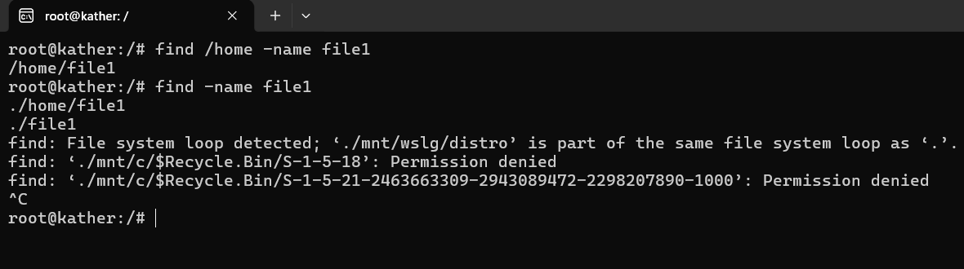
Creating and editing file1 with nano and vi
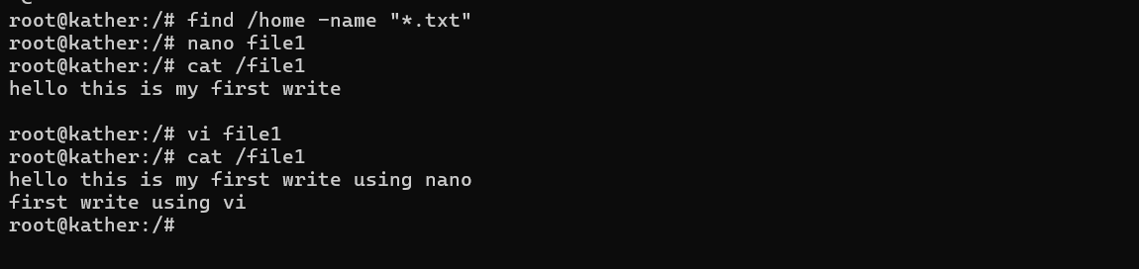
Searching file contents with grep
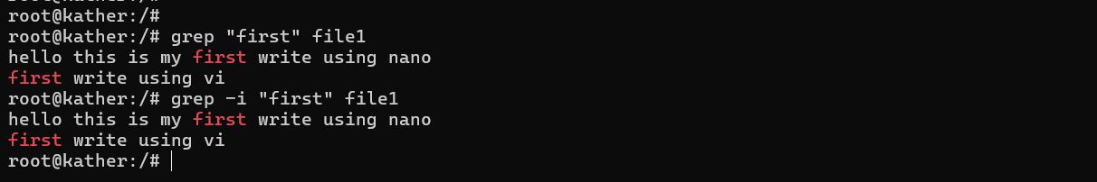
Changing permissions with chmod
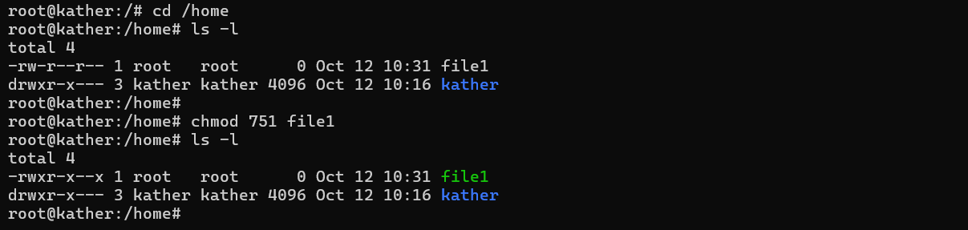
Creating a group and changing ownership with chown
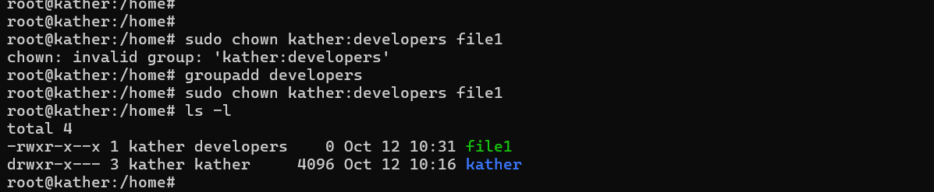
Viewing processes with ps
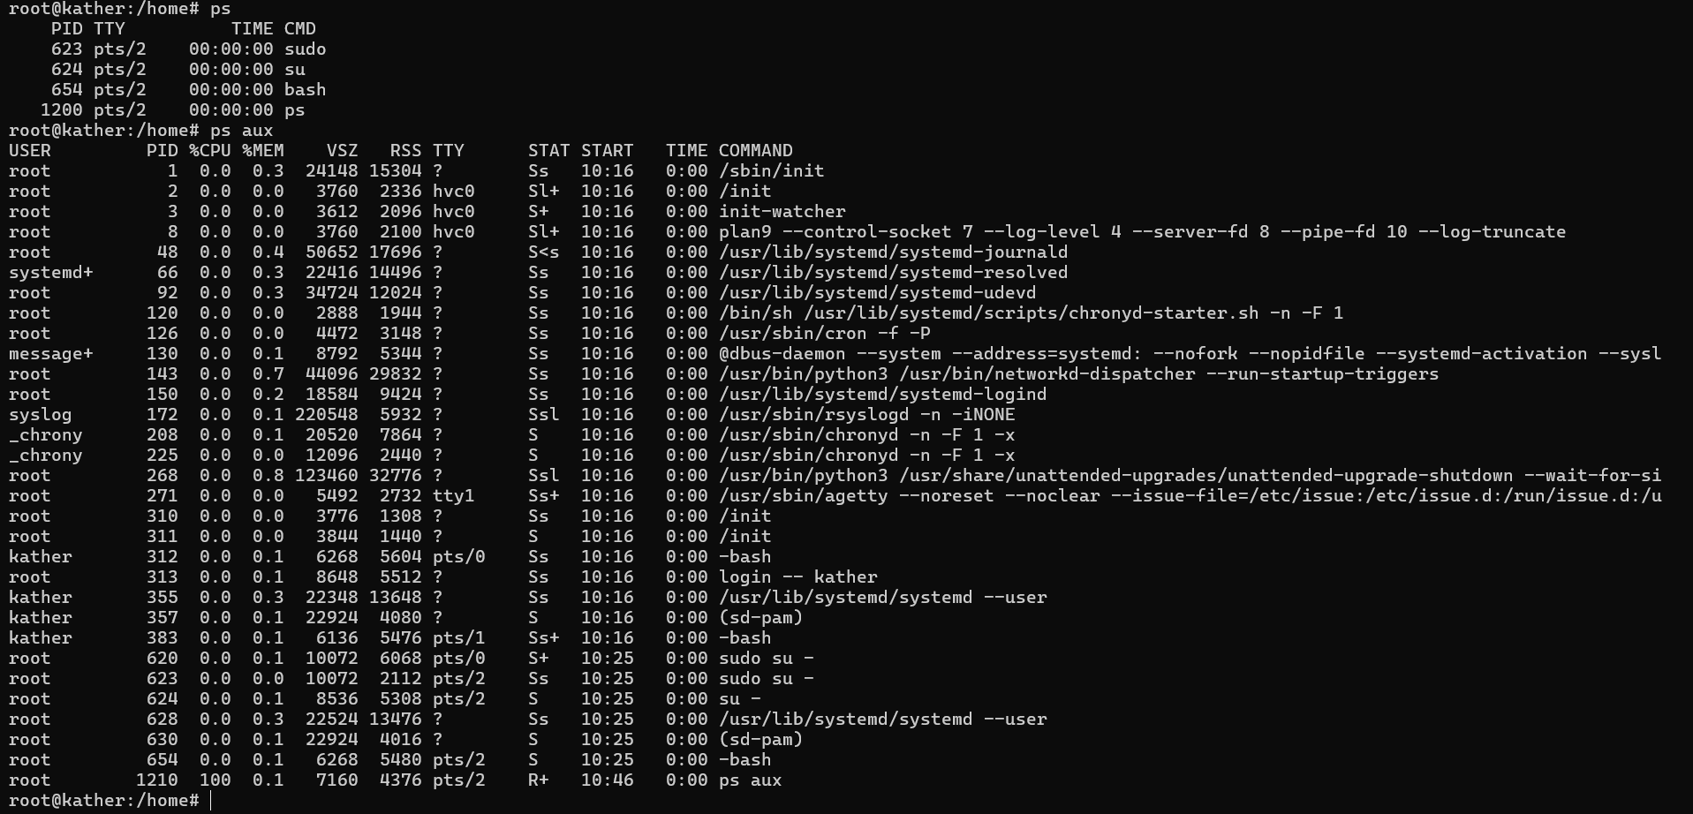
Checking disk space with df
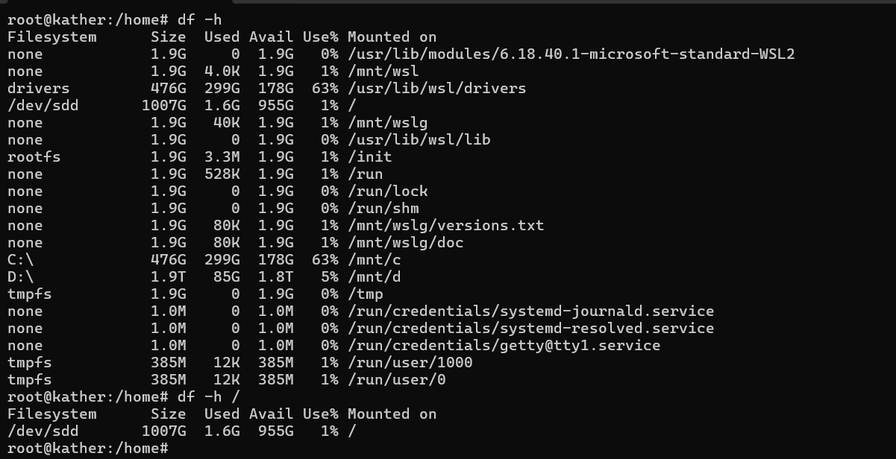
Checking RAM and swap with free
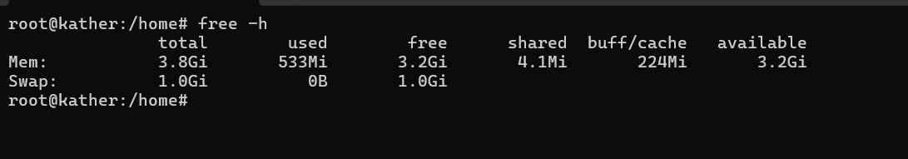
Checking directory size with du
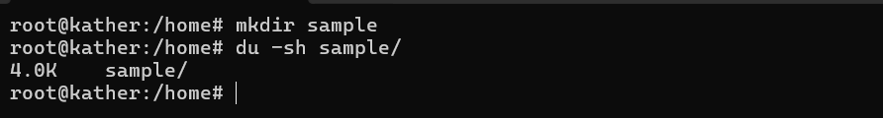
Creating a tar archive
